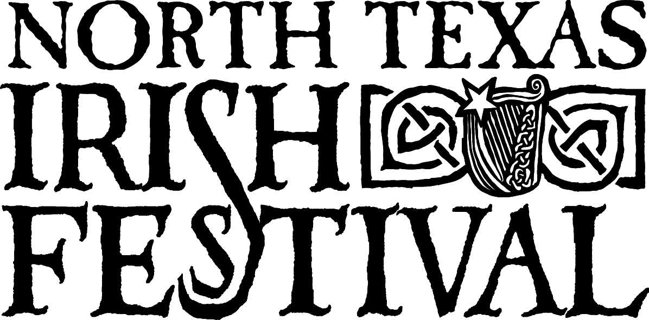

2005 Schedule of Entertainment

Please note.
While every effort will be made to follow the published schedule, the SCMA reserves the right to make any changes to the published times, performers, stage locations or opening hours of the festival without notice at any time prior to or during the event. The SCMA accepts no responsibility for any changes made, and all ticket sales are final.

Friday, March 4th
Shannon Stage |  | Star & Harp Pub Stage
6:30  8:30  9:30 | The Pale Whale Review  The McKrells  The Elders | 7:00  8:00  9:00 | Gallus  Cairde  Bluebonnet Plague

Saturday, March 5th
Shannon Stage |  | Shamrock Stage
11:00  12:15  1:30  2:45  4:00  5:15  6:30  7:45  9:00  10:15 | Need Fire  North Texas Caledonian  Pipes & Drums  The (Scottish) Rogues  Kula  The Elders  Jiggernaut  Brothers 3  The McKrells  The (Scottish) Rogues  The Elders | 11:00  12:00  1:00  2:00  3:00  4:00  5:00  6:00  7:00  8:00  9:00  10:00 | Michael Harrison  Sarah Dinan  Spirits of the House  Sliabh Notes  Téada  Beyond the Pale  Tim O'Brien  Sliabh Notes  John Williams & Dean Magraw  Ed Miller  Tim O'Brien  Téada
Trinity Stage |  | Star & Harp Pub Stage
11:00  12:00  1:00  2:00  3:00  4:00  5:00  6:00  7:00  8:00  9:00  10:00 | Bounds Street  Jed Marum  The McKrells  Ed Miller  Bluebonnet Plague  Paddy Keenan  Jim Flanagan  Trinity River Whalers  Jed Marum  Paddy Keenan  Legacy  Tuberville | 11:00  12:00  1:00  2:00  3:00  4:00  5:00  6:00  7:00  8:00  9:00 | Gallus  Jigsaw  Tuberville  Tinsmith  The Irish Rogues  Behan  Cairde  Round the House  Seamus Stout  Threadneedle Street  Amberhawke
Emerald Dance Stage |  | Tara Cultural Stage
11:00  12:00  1:00  2:00  3:00  4:00  5:00  6:00  7:00  8:00  9:00  10:00 | WindDance  San Antonio Irish Dancers  Shandon School  Jackson Irish Dancers  Emerald School of Irish Dance  Workshop - Catherine Sherer  WindDance  Ceili - till close | 11:00  12:00  12:45  1:15  2:00  2:30  3:00  3:30  4:30  5:30  6:30 | Play - "Dark of the Moon"  Storytelling - John Burleson  Cór Gaeilge  Storytelling - Liz Covington  Accordion workshop - Mark Kenneth  Storytelling - Gary Whitaker  Play - "Dark of the Moon"  Bodhran workshop - Albert Alfonso and Mark Stone  Guitar workshop - John Burleson and Don Penzien  Dulcimer workshop - Russell Cook

Urchin Street Stage
11:00  12:00  12:45  1:15  2:00  2:30  3:15  3:45  4:30  5:15  6:00 | ParaCelt  Lady Amber  Liz Covington  Edie & Dee  Gary Whitaker  Behan - Next Generation  John Burleson  Michael Price  Jonquele Jones  Michael Harrison  Roots of Green

Sunday, March 6th
Shannon Stage |  | Shamrock Stage
12:00  1:15  2:30  3:45  5:00  6:15  7:30 | Behan  Round the House  Seamus Stout  Need Fire  Brothers 3  Kula  Jiggernaut | 12:00  1:00  2:00  3:00  4:00  5:00  6:00  7:00  8:00 | Jim Flanagan  Sliabh Notes  Tim O'Brien  Téada  Ed Miller  Sliabh Notes  Tim O'Brien  Michael Harrison  Téada
Trinity Stage |  | Star & Harp Pub Stage
12:00  1:00  2:00  3:00  4:00  5:00  6:00  7:00  8:00 | Threadneedle Street  Jed Marum  Ed Miller  Paddy Keenan  Jed Marum  The McKrells  Bounds Street  Paddy Keenan  John Williams & Dean Magraw | 12:00  1:00  2:00  3:00  4:00  5:00  6:00  7:00 | Glass & Taft  Legacy  The Irish Rogues  Sarah Dinan  Glass & Taft  Amberhawke  Jigsaw  Tinsmith
Emerald Dance Stage |  | Tara Cultural Stage
12:00  1:00  2:00  3:00  4:00  5:00  6:00 | San Antonio Irish Dancers  Jackson Irish Dancers  WindDance  Hibernia School of Irish Dance &  The Iverin Dance Company  Emerald School of Irish Dance  Shandon School of Irish Dance  McTeggart Irish Dancers | 12:00  12:45  1:15  2:00  2:45  3:30  4:00  4:45  5:15 | Play - "Dark of the Moon"  Storytelling - John Burleson  Cór Gaeilge  Flute & Whistle workshop - Peggy Turner & Jeff Baker  Appalachian clogging workshop - Claire Zucker  Storytelling - Liz Covington & Gary Whitaker  Fiddle workshop - Valerie Plested & Tim Avalon  Storytelling workshop  Banjo workshop - Lee Thomas & John Scott

Urchin Street Stage
12:00  1:00  1:45  2:15  3:00  3:30  4:15  4:45  5:30  6:15 | Michael Price  Steve Johnson  Liz Covington & Gary Whitaker  Lady Amber  Rebekah Passmore  Eddie & Dee  John Burleson  Calamity Road  Jonquele Jones  Wee Wild Fiddlers

